**.NET Assignment - 1**

**Installation & Basic Tutorial**

1. Successfully run in VS Code

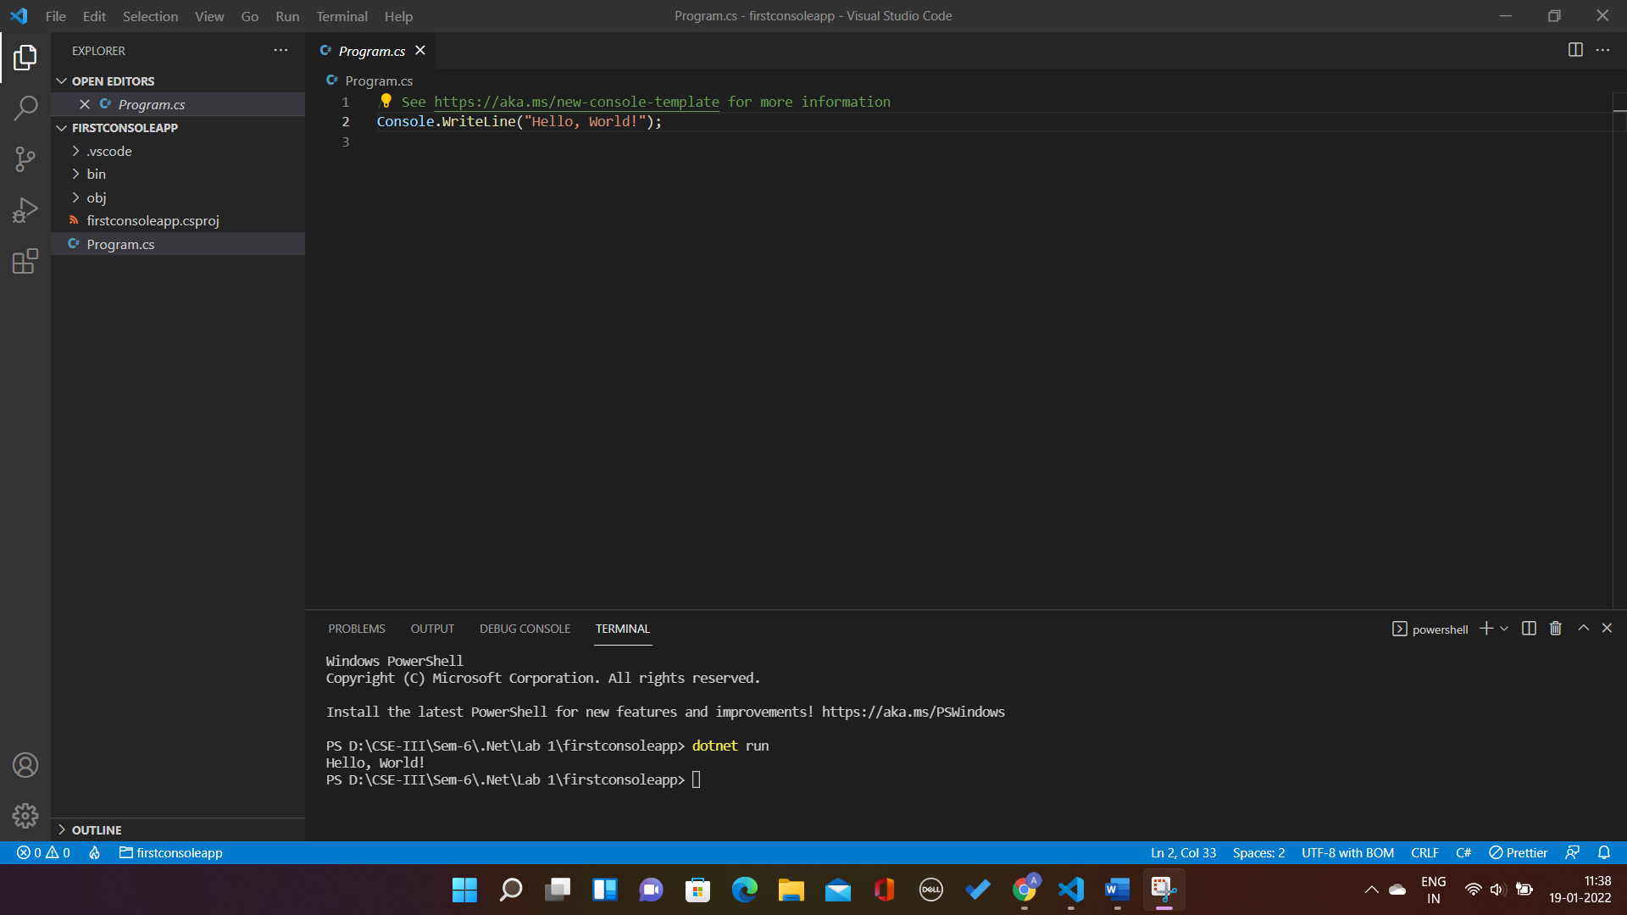

**.NET In-Browser Tutorial**

**Step 1**: Introduction

Code :

Console.WriteLine("Hello World!");

Output :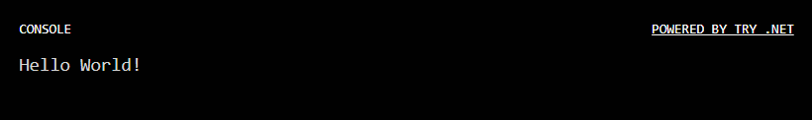

**Step 2** : Strings

Code :

Console.WriteLine("Hello Aishwarya!");

Output :

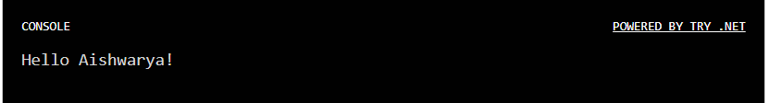

**Step 3** : Variables

Code :

var name = "Aishwarya";

Console.WriteLine("Hello " + name + "!");

Output :



**Step 4** : String interpolation

Code :

var name = "Aishwarya";

Console.WriteLine($"Hello {name}!");

Output :



**Step 5** : Methods

Code :

var name = "Aishwarya";

Console.WriteLine($"Hello {name.ToUpper()}!");

Output :

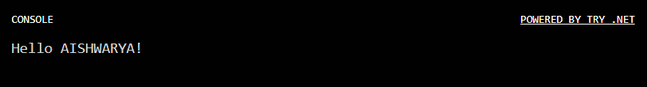

**Step 6** : Collections

Code :

var names = new[] { "Aishwarya", "Felipe", "Emillia" };

foreach (var name in names)

{

Console.WriteLine($"Hello {name.ToUpper()}!");

}

Output :

